User Guide for Trias Interface

This is a user guide for the visual interface created for the Trias algorithm. We mention that our contribution is limited to this user interface, without affecting the algorithm in any way.

1. **Starting window**

Upon launching the program a window such as the one in Fig. 1 is shown. The user may use this window to select the type of task (concept neighborhoods or just concepts) and the data source (file or database).

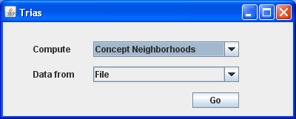

Figure

Tasks:

* computing concept neighborhoods outputs a file containing the graph of concept neighborhoods coresponding to a triadic context;
* computing concepts outputs a file containing all triadic concepts coresponding to a triadic context (this is not implemneted yet).

Data sources:

* if the data source is a file, it must have the following format: on each line there should be a triple (elements separated by a specific separator, see section 2 for details) representing an element of the ternary relation specifying the context, so the context is defined by enumerating all elements of the ternary relation;
* if the data source is a database table, it must have three columns (it may have more but only three are selected), each row representing an element of the ternary relation specifying the context, so the context is defined by enumerating all elements of the ternary relation; also if database source is used, there must be a file called *database.properties* in the working directory containing the properties *db.url, db.username,* and *db.password* of the database connection (we have attached an example of such a file).

1. **Concept neighborhoods generation using a file data source**

The window will look like the one in Fig. 2. It is used to specify all the required parameters for the computation.

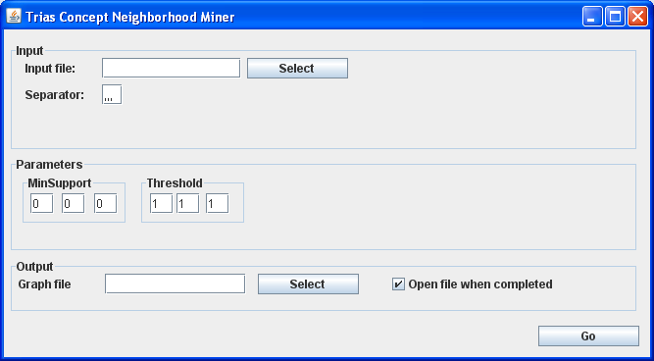

Figure

* **Input file:** the path of the file containing the data (having the format specified in section 1) – it can also be selected by browsing the file system (press select for this).
* **Separator:** the separator for the three elements (it can be any string); be advised that the separator must not appear in any of the elements or else there will be an error.
* **MinSuport:** the minimum support for each of the three dimensions of the context (only concepts that have at least minSuport number of elements in the correspondig dimension will be selected).
* **Threshold:** the threshold specifies the maximum number of different elements in each dimension such that two concepts will be connected.
* **Graph file:** the output file where the neighborhoods graph will be stored. Its path can be given manually or the file can be selected from the file system using the select button.
* **Open file when completed:** if this is checked the program will attempt to open the graph file using Graphviz upon completion. If graphviz is not installed there will be an error.

**Note:** We have included an example of an input file.The three elements are *pacient identification, topography,* and*, morphology* of the tumor. The separator is three commas (,,,).

1. **Concept neighborhoods generation using database source**

The window will look like the one in Fig. 3. It is used to specify all the required parameters for the computation.

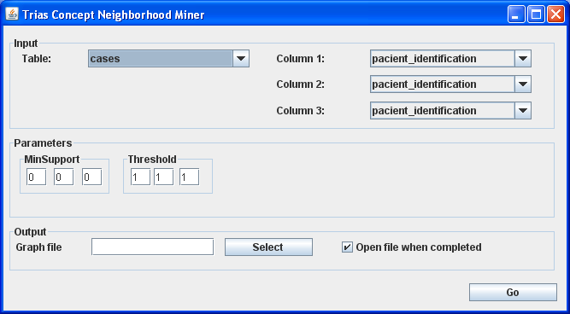

Figure

* **Table:** this combo box can be used to select the table that contains the data (out of all tables in the database).
* **Column 1/2/3:** these combo boxes can be used to select the three columns that contain the three dimensions of the context. Each row in the table is interpretted as an element of the ternary relation defining the context.
* **MinSuport:** the minimum support for each of the three dimensions of the context (only concepts that have at least minSuport number of elements in the correspondig dimension will be selected).
* **Threshold:** the threshold specifies the maximum number of different elements in each dimension such that two concepts will be connected.
* **Graph file:** the output file where the neighborhoods graph will be stored. Its path can be given manually or the file can be selected from the file system using the select button.
* **Open file when completed:** if this is checked the program will attempt to open the graph file using Graphviz upon completion. If graphviz is not installed there will be an error.